**Banco de Dados**

* Diagrama Entidade-Relacionamento

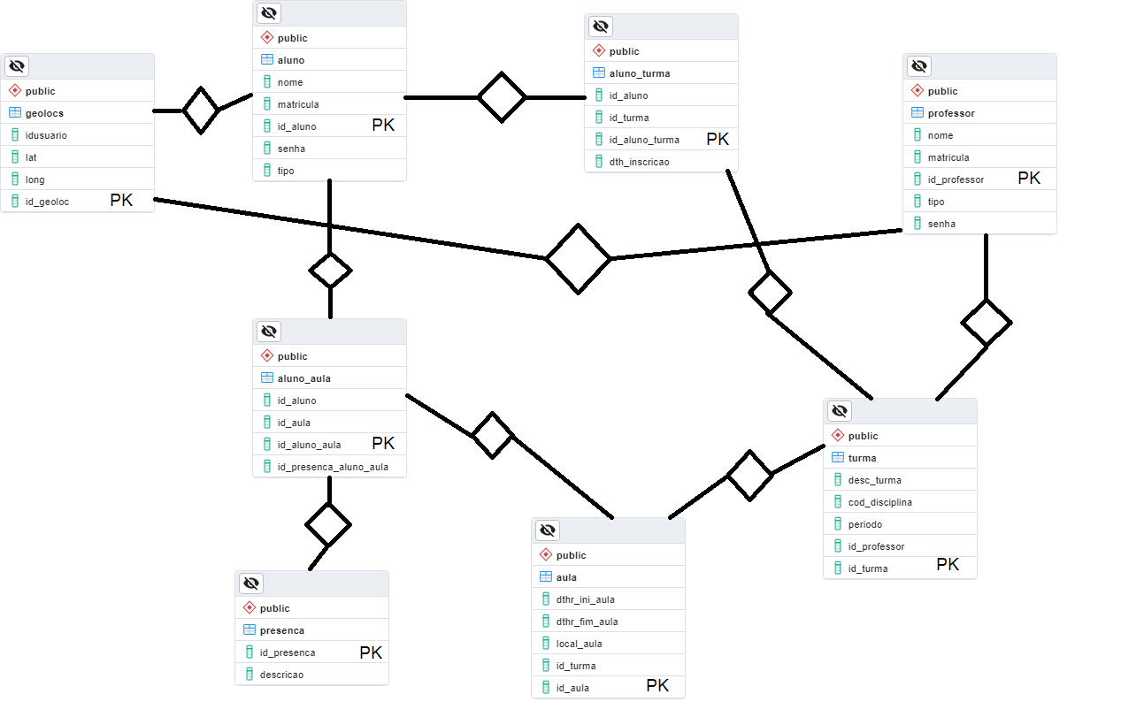

* Script SQL



--

-- PostgreSQL database dump

--

-- Dumped from database version 15.4

-- Dumped by pg_dump version 15.4

-- Started on 2023-11-22 22:57:48

SET statement_timeout = 0;

SET lock_timeout = 0;

SET idle_in_transaction_session_timeout = 0;

SET client_encoding = 'UTF8';

SET standard_conforming_strings = on;

SELECT pg_catalog.set_config('search_path', '', false);

SET check_function_bodies = false;

SET xmloption = content;

SET client_min_messages = warning;

SET row_security = off;

--

-- TOC entry 247 (class 1255 OID 16665)

-- Name: criar_aula(date, integer); Type: FUNCTION; Schema: public; Owner: doadmin

--

CREATE FUNCTION public.criar_aula(data_p date, id_turma_p integer) RETURNS void

LANGUAGE plpgsql

AS $$

DECLARE

id_aula_v INT;

aluno_rec RECORD;

BEGIN

-- Inserir um novo registro na tabela Aula

INSERT INTO Aula (dthr_ini_aula, id_turma) VALUES (data_p, id_turma_p);

SELECT id_aula INTO id_aula_v FROM Aula WHERE dthr_ini_aula = data_p AND id_turma_p = id_turma_p;

-- Inserir um novo registro na tabela aluno_aula para cada aluno

FOR aluno_rec IN (SELECT id_aluno FROM Aluno)

LOOP

INSERT INTO aluno_aula (id_aula, id_presenca_aluno_aula, id_aluno)

VALUES (id_aula_v, 0, aluno_rec.id_aluno);

END LOOP;

END;

$$;

ALTER FUNCTION public.criar_aula(data_p date, id_turma_p integer) OWNER TO doadmin;

--

-- TOC entry 245 (class 1255 OID 16527)

-- Name: inscrevealunoturma(integer, integer); Type: PROCEDURE; Schema: public; Owner: doadmin

--

CREATE PROCEDURE public.inscrevealunoturma(IN num_aluno integer, IN num_turma integer)

LANGUAGE plpgsql

AS $$

declare

status int;

existeAluno int;

existeTurma int;

jaInscrito int;

BEGIN

existeAluno := COUNT(*) FROM aluno a where a.id_aluno = num_aluno;

existeTurma := COUNT(*) FROM turma a where a.id_turma = num_turma;

jaInscrito := COUNT(*) FROM aluno_turma a where a.id_turma = num_turma and a.id_aluno = num_aluno;

RAISE NOTICE 'testando:% e % e %',existeAluno,existeTurma,jaInscrito;

--Aluno nao encontrado

IF existeAluno = 0 THEN

RAISE exception 'Aluno não encontrado';

END IF;

-- Turma não encontrada

IF existeTurma = 0 THEN

RAISE exception 'Turma não encontrada';

END IF;

-- Já inscrito

IF jaInscrito > 0 THEN

RAISE notice 'Já cadastrado';

else

insert into aluno_turma (id_aluno, id_turma, dth_inscricao) values (num_aluno, num_turma, CURRENT_TIMESTAMP::timestamp);

END IF;

RAISE NOTICE '1';

EXCEPTION

WHEN OTHERS THEN

-- Handle exceptions here if needed

RAISE NOTICE '0';

END $$;

ALTER PROCEDURE public.inscrevealunoturma(IN num_aluno integer, IN num_turma integer) OWNER TO doadmin;

--

-- TOC entry 250 (class 1255 OID 16697)

-- Name: lista_alunos_turma(integer); Type: FUNCTION; Schema: public; Owner: doadmin

--

CREATE FUNCTION public.lista_alunos_turma(num_turma integer) RETURNS TABLE(nome character varying, desc_turma character varying, matricula character varying, id_aluno integer)

LANGUAGE plpgsql

AS $$

declare

status int;

BEGIN

RETURN QUERY

select a.nome, c.desc_turma ,a.matricula,a.id_aluno from aluno a

inner join aluno_turma b on a.id_aluno = b.id_aluno

inner join turma c on b.id_turma = c.id_turma

where b.id_turma = num_turma order by a.nome;

/*inner join turma c on b.id_turma = c.id_turma

inner join aluno_aula d on a.id_aluno = d.id_aluno and d.id_aula = num_aula;*/

END $$;

ALTER FUNCTION public.lista_alunos_turma(num_turma integer) OWNER TO doadmin;

--

-- TOC entry 251 (class 1255 OID 16713)

-- Name: listaalunoscompresenca(integer); Type: FUNCTION; Schema: public; Owner: doadmin

--

CREATE FUNCTION public.listaalunoscompresenca(num_aula integer) RETURNS TABLE(nome character varying, matricula character varying, id_aluno integer, presenca text)

LANGUAGE plpgsql

AS $$

declare

status int;

BEGIN

return query

select b.nome,b.matricula,a.id_aluno ,concat(presenca_aluno (a.id_aluno,d.id_turma),'%') as presenca from aluno_aula a

inner join aluno b on a.id_aluno = b.id_aluno

inner join aula c on a.id_aula = c.id_aula

inner join turma d on c.id_turma = d.id_turma

where a.id_aula = num_aula;

END

$$;

ALTER FUNCTION public.listaalunoscompresenca(num_aula integer) OWNER TO doadmin;

--

-- TOC entry 249 (class 1255 OID 16694)

-- Name: listaalunoscompresenca(integer, integer); Type: FUNCTION; Schema: public; Owner: doadmin

--

CREATE FUNCTION public.listaalunoscompresenca(num_aula integer, num_disciplina integer) RETURNS TABLE(nome character varying, matricula character varying, id_aluno integer, presenca double precision)

LANGUAGE plpgsql

AS $$

declare

BEGIN

RETURN QUERY

select a.nome,a.matricula,a.id_aluno, cast(presenca_aluno (a.id_aluno,b.id_turma) as char(3))+'%' as presenca from aluno a

inner join aluno_turma b on a.id_aluno = b.id_aluno

inner join turma c on b.id_turma = c.id_turma

inner join aluno_aula d on a.id_aluno = id_aluno and a.id_aula = num_aula;

END $$;

ALTER FUNCTION public.listaalunoscompresenca(num_aula integer, num_disciplina integer) OWNER TO doadmin;

--

-- TOC entry 248 (class 1255 OID 16692)

-- Name: presenca_aluno(integer, integer); Type: FUNCTION; Schema: public; Owner: doadmin

--

CREATE FUNCTION public.presenca_aluno(num_aluno integer, num_turma integer) RETURNS double precision

LANGUAGE plpgsql

AS $$

declare

quantidade_aulas float;

quantidade_presencas float;

porcentagem float;

status int;

BEGIN

quantidade_aulas := COUNT(*) FROM aula a where a.id_turma = num_turma;

quantidade_presencas := COUNT(*) FROM aluno_aula a

inner join aula b on a.id_aula = b.id_aula

where b.id_turma = num_turma and a.id_aluno = num_aluno

and a.id_presenca_aluno_aula != 0;

porcentagem := (quantidade_presencas/quantidade_aulas)*100;

return porcentagem;

END $$;

ALTER FUNCTION public.presenca_aluno(num_aluno integer, num_turma integer) OWNER TO doadmin;

--

-- TOC entry 246 (class 1255 OID 16549)

-- Name: relatorio_de_turma(integer); Type: FUNCTION; Schema: public; Owner: doadmin

--

CREATE FUNCTION public.relatorio_de_turma(ident_turma integer) RETURNS TABLE(id_aula integer, data_aula timestamp without time zone, id_turma integer)

LANGUAGE plpgsql

AS $$

BEGIN

--tabelas temporarias necessarias:

CREATE TEMPORARY TABLE alunos(ident_aluno int);

CREATE TEMPORARY TABLE aulas(id_aula int, data_aula timestamp, id_turma int);

--pegando os alunos

insert into alunos select a.id_aluno from aluno_turma a where a.id_turma = ident_turma;

insert into aulas select a.id_aula, a.dthr_ini_aula, a.id_turma from aula a where a.id_turma = ident_turma;

-- Retornar um conjunto de resultados no final

RETURN QUERY

SELECT a.id_aula, a.data_aula , a.id_turma

FROM aulas a;

drop table alunos;

drop table aulas;

-- Mais operações, se necessário

-- ...

END;

$$;

ALTER FUNCTION public.relatorio_de_turma(ident_turma integer) OWNER TO doadmin;

SET default_tablespace = '';

SET default_table_access_method = heap;

--

-- TOC entry 221 (class 1259 OID 16466)

-- Name: aluno; Type: TABLE; Schema: public; Owner: doadmin

--

CREATE TABLE public.aluno (

nome character varying(100),

matricula character varying(20),

id_aluno integer NOT NULL,

senha character varying(20),

tipo character varying(1)

);

ALTER TABLE public.aluno OWNER TO doadmin;

--

-- TOC entry 229 (class 1259 OID 16483)

-- Name: aluno_aula; Type: TABLE; Schema: public; Owner: doadmin

--

CREATE TABLE public.aluno_aula (

id_aluno integer,

id_aula integer,

id_aluno_aula integer NOT NULL,

id_presenca_aluno_aula integer

);

ALTER TABLE public.aluno_aula OWNER TO doadmin;

--

-- TOC entry 228 (class 1259 OID 16482)

-- Name: aluno_aula_id_aluno_aula_seq; Type: SEQUENCE; Schema: public; Owner: doadmin

--

ALTER TABLE public.aluno_aula ALTER COLUMN id_aluno_aula ADD GENERATED BY DEFAULT AS IDENTITY (

SEQUENCE NAME public.aluno_aula_id_aluno_aula_seq

START WITH 1

INCREMENT BY 1

NO MINVALUE

NO MAXVALUE

CACHE 1

);

--

-- TOC entry 220 (class 1259 OID 16465)

-- Name: aluno_id_aluno_seq; Type: SEQUENCE; Schema: public; Owner: doadmin

--

ALTER TABLE public.aluno ALTER COLUMN id_aluno ADD GENERATED BY DEFAULT AS IDENTITY (

SEQUENCE NAME public.aluno_id_aluno_seq

START WITH 1

INCREMENT BY 1

NO MINVALUE

NO MAXVALUE

CACHE 1

);

--

-- TOC entry 231 (class 1259 OID 16487)

-- Name: aluno_turma; Type: TABLE; Schema: public; Owner: doadmin

--

CREATE TABLE public.aluno_turma (

id_aluno integer,

id_turma integer,

id_aluno_turma integer NOT NULL,

dth_inscricao timestamp without time zone

);

ALTER TABLE public.aluno_turma OWNER TO doadmin;

--

-- TOC entry 230 (class 1259 OID 16486)

-- Name: aluno_turma_id_aluno_turma_seq; Type: SEQUENCE; Schema: public; Owner: doadmin

--

ALTER TABLE public.aluno_turma ALTER COLUMN id_aluno_turma ADD GENERATED BY DEFAULT AS IDENTITY (

SEQUENCE NAME public.aluno_turma_id_aluno_turma_seq

START WITH 1

INCREMENT BY 1

NO MINVALUE

NO MAXVALUE

CACHE 1

);

--

-- TOC entry 227 (class 1259 OID 16479)

-- Name: aula; Type: TABLE; Schema: public; Owner: doadmin

--

CREATE TABLE public.aula (

dthr_ini_aula timestamp without time zone,

dthr_fim_aula timestamp without time zone,

local_aula point,

id_turma integer,

id_aula integer NOT NULL

);

ALTER TABLE public.aula OWNER TO doadmin;

--

-- TOC entry 226 (class 1259 OID 16478)

-- Name: aula_id_aula_seq; Type: SEQUENCE; Schema: public; Owner: doadmin

--

ALTER TABLE public.aula ALTER COLUMN id_aula ADD GENERATED BY DEFAULT AS IDENTITY (

SEQUENCE NAME public.aula_id_aula_seq

START WITH 1

INCREMENT BY 1

NO MINVALUE

NO MAXVALUE

CACHE 1

);

--

-- TOC entry 232 (class 1259 OID 16500)

-- Name: geolocs; Type: TABLE; Schema: public; Owner: doadmin

--

CREATE TABLE public.geolocs (

idusuario integer,

lat double precision,

long double precision,

id_geoloc integer

);

ALTER TABLE public.geolocs OWNER TO doadmin;

--

-- TOC entry 233 (class 1259 OID 16684)

-- Name: presenca; Type: TABLE; Schema: public; Owner: doadmin

--

CREATE TABLE public.presenca (

id_presenca integer,

descricao character varying(50)

);

ALTER TABLE public.presenca OWNER TO doadmin;

--

-- TOC entry 223 (class 1259 OID 16471)

-- Name: professor; Type: TABLE; Schema: public; Owner: doadmin

--

CREATE TABLE public.professor (

nome character varying(100),

matricula character varying(20),

id_professor integer NOT NULL,

tipo character varying(1),

senha character varying(20)

);

ALTER TABLE public.professor OWNER TO doadmin;

--

-- TOC entry 222 (class 1259 OID 16470)

-- Name: professor_id_professor_seq; Type: SEQUENCE; Schema: public; Owner: doadmin

--

ALTER TABLE public.professor ALTER COLUMN id_professor ADD GENERATED BY DEFAULT AS IDENTITY (

SEQUENCE NAME public.professor_id_professor_seq

START WITH 1

INCREMENT BY 1

NO MINVALUE

NO MAXVALUE

CACHE 1

);

--

-- TOC entry 225 (class 1259 OID 16475)

-- Name: turma; Type: TABLE; Schema: public; Owner: doadmin

--

CREATE TABLE public.turma (

desc_turma character varying(100),

cod_disciplina character varying(10),

periodo character(6),

id_professor integer,

id_turma integer NOT NULL

);

ALTER TABLE public.turma OWNER TO doadmin;

--

-- TOC entry 224 (class 1259 OID 16474)

-- Name: turma_id_turma_seq; Type: SEQUENCE; Schema: public; Owner: doadmin

--

ALTER TABLE public.turma ALTER COLUMN id_turma ADD GENERATED BY DEFAULT AS IDENTITY (

SEQUENCE NAME public.turma_id_turma_seq

START WITH 1

INCREMENT BY 1

NO MINVALUE

NO MAXVALUE

CACHE 1

);

-- Completed on 2023-11-22 22:58:01

--

-- PostgreSQL database dump complete

--